McVan Inc.
35 Frank Mossberg Drive
Attleboro, MA 02703
Phone: 800-322-8781
Fax: 800-730-2822

Patron Saint Engraving Form

Order Date__________________________________
Customer Acct. #_____________________________
Customer Name______________________________
Address_____________________________________
City________________________________________
State_________ Zip__________________________

Please fill out the following if we are shipping directly to your customer:

Name______________________________________
Address____________________________________
State________ Zip___________________________
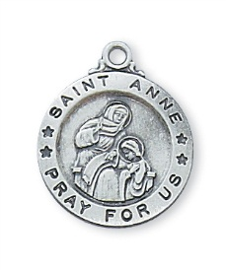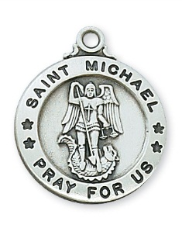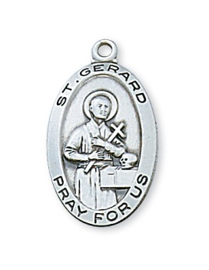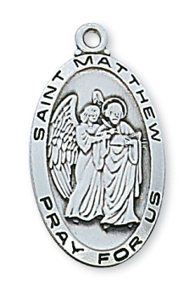
L700 Series L600 Series L500 Series L550 Series

Engravable Patron Saints can be found on pages 6 – 9 in our main catalog.
All medals can be engraved up to 3 lines of type and 13 characters
(including spaces) per line.

Item #_____________________ Check Font: Block_____________ Script______________

Line 1: ___ ___ ___ ___ ___ ___ ___ ___ ___ ___ ___ ___ ___
Line 2: ___ ___ ___ ___ ___ ___ ___ ___ ___ ___ ___ ___ ___
Line 3: ___ ___ ___ ___ ___ ___ ___ ___ ___ ___ ___ ___ ___

Special Instructions:_________________________________________
__________________________________________________________

__________________________________________________________

Visit our website: www.mcvaninc.com

